Week 11

18.Create a procedure to find reverse of a given number
- Create a procedure to update the salaries of all employees whose salary is between 25000 to 50000

PROCEDURES:-

A procedure or a function is a logically grouped set of SQL and PL/SQL statements that perform a specific task.

. PL/SQL provides two kinds of subprograms −
- Functions − These subprograms return a single value; mainly used to compute and return a value.
- Procedures − These subprograms do not return a value directly; mainly used to perform an action. (Or)

A procedure is a named pl\sql block that accepts some input performs some action on database and may or may not return a value.

Syntax:-

CREATE [OR REPLACE] PROCEDURE <procedure_name>
(<parameter_name> [IN | OUT | IN OUT] <data type> , ...)
{IS | AS}

<Variable> declarations;

<Constant> declarations;
BEGIN
procedure_body;

[EXCEPTION
exception block;]

END [procedure_name];

Eg:- create a procedure to print hello world

CREATE OR REPLACE PROCEDURE greetings

AS

BEGIN

dbms_output.put_line('Hello World!');

END;

/

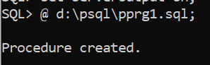

Executing a Standalone Procedure

A standalone procedure can be called in two ways −
- Using the EXECUTE keyword
- Calling the name of the procedure from a PL/SQL block

The above procedure named 'greetings' can be called with the EXECUTE keyword as −

EXECUTE greetings;

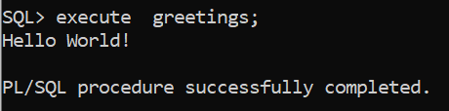

2nd method to execute procedures:-

The procedure can also be called from another PL/SQL block −

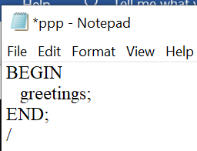

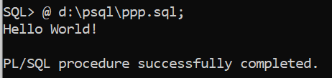

Deleting a Standalone Procedure

A standalone procedure is deleted with the DROP PROCEDURE statement. Syntax for deleting a procedure is −

DROP PROCEDURE procedure-name;

You can drop the greetings procedure by using the following statement −

DROP PROCEDURE greetings;

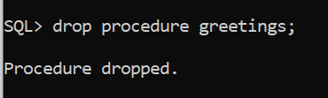

- A procedure may be passed multiple parameters.
- IN | OUT | IN OUT specifies the mode of the parameter.
- procedure_body contains the SQL and PL/SQL statements to perform the procedure's task.
- You may pick one of the following modes for each parameter:
- IN is the default mode for a parameter.
- IN indicates that the parameter will accept a value from the user.
- OUT indicates that the parameter will return a value to the user.
- IN OUT parameters indicates that the parameter will either accept a value from the user or return a value to the user
- An IN OUT parameter passes an initial value to a subprogram and returns an updated value to the caller. It can be assigned a value and the value can be read.
************************************************************************************************
Eg:-
/* create a procedure to increment all the employee salaries by 10*/
Step1:- create a emp table and insert data as shown below

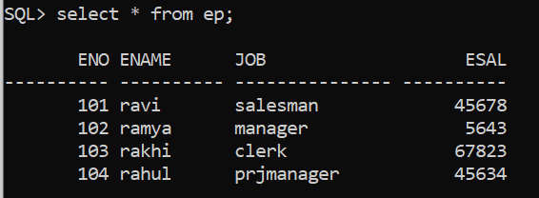

create or replace procedure raissal
is
begin
update ep set esal =esal+10;
commit;
end;
/

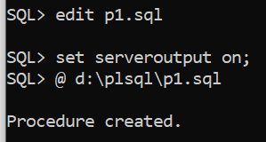

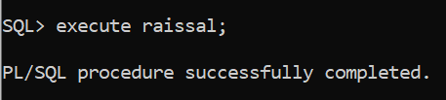

Check the ep table whether esal is increment with 10 or not

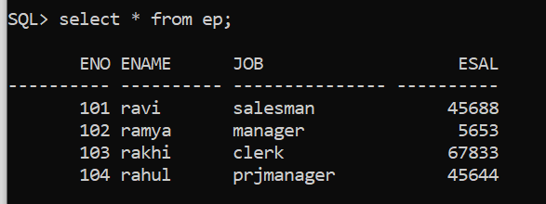
********************************************************

Eg:-1) program using IN & OUT mode parameters

DECLARE

a number;

b number;

c number;

PROCEDURE findMin(x IN number, y IN number, z OUT number) IS

BEGIN

IF x < y THEN

z:= x;

ELSE

z:= y;

END IF;

END;

BEGIN

a:= 23;

b:= 45;

findMin(a, b, c);

dbms_output.put_line(' Minimum of (23, 45) : ' || c);

END;

/

Output:-

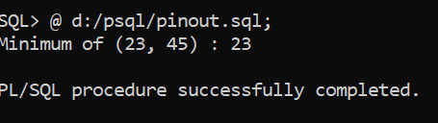

***********************************************************************************

Eg:-2) program using IN OUT mode parameters

DECLARE

a number;

PROCEDURE squareNum(x IN OUT number) IS

BEGIN

x := x * x;

END;

BEGIN

a:= 23;

squareNum(a);

dbms_output.put_line(' Square of (23): ' || a);

END;

/

Output:-

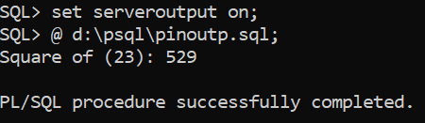

************************************************************

Week 11:

18) Create a procedure to find reverse of a given number

create or replace procedure rev( n in number, rev out number ) as

n1 number;

r number;

begin

n1:=n;

rev:=0;

while(n1!=0)

loop

r:=mod(n1,10);

rev:=rev*10+r;

n1:=floor(n1/10);

end loop;

end;

/

Output:-

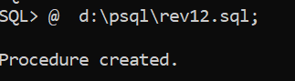

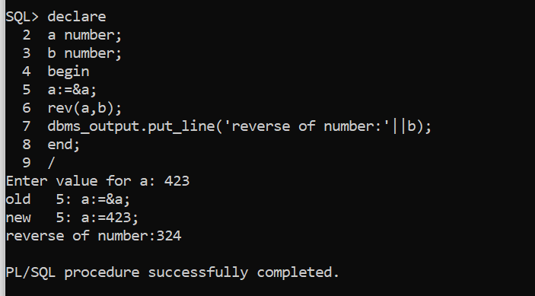

*****************************************************************************************

Week11:

19) Create a procedure to update the salaries of all employees whose salary is between 25000 to 50000?

First of all, create employee table with attributes empid ,empname ,salary & deptno and insert values in it. Later ,execute the following code.

SQL>edit sal.sql

SUB PROGRAM:

create or replace procedure sal as

cursor cur is select empid ,empname,salary,deptno from employee;

a employee.empid%type;

b employee.empname%type;

c employee.salary%type;

d employee.deptno%type;

e number:=0;

begin

open cur;

loop

fetch cur into a,b,c,d;

if (c>25000 and c<50000) then

update employee set salary =salary+2500;

e:=e+1;

fetch cur into a,b,c,d;

dbms_output.put_line('empid is '|| a || ' empname is '|| b||' salary is '|| c||'deptno'|| d);

end if;

exit when cur%notfound;

end loop;

close cur;

dbms_output.put_line('count'||e);

end;

MAIN PROGRAM:

SQL>declare

begin

sal;

end;

/

***************************************************************

Week 12

20.Create a procedure to demonstrate IN, OUT and INOUT parameters

21.Create a function to check whether a given string is palindrome or not.

Week12:

20)a) create a procedure to demonstrate INOUT parameter.

create or replace procedure p11(a in out number)

is

begin

a:=a*a;

end;

/

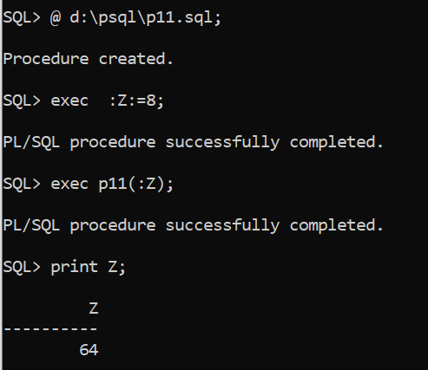

*************************************************************************************

Week12:-

20) b)Create a procedure to demonstrate IN, OUT and IN OUTparameter.

SQL>edit week12.sql

SUB PROGRAM:

create or replace procedure findmin(x in number,y in number,z in out number) as

begin

if x<y then

z:=x;

else

z:=y;

end if;

end;

MAIN PROGRAM:

SQL>declare

a number;

b number;

c number;

begin

a:=&a;

b:=&b;

findmin(a,b,c);

dbms_output.put_line('minimum value:'||c);

end;

/

*****************************************************

Functions:-
- Functions created by user are called user defined functions.
- When predefine functions not meeting our requirements then we create our own functions called user defined functions
- A function is also a named pl\sql block that accepts some input performs some calculation and must return a value.
- Functions are created: a)for calculations b) to fetch value from database.

Syntax:-

Create or replace function <name>(parameters ) return<type>

Is

Declaration part;

Begin

Statements;

Return expr;

End;

/

Functions:-

A function is same as a procedure except that it returns a value.

Syntax:-

CREATE [OR REPLACE] FUNCTION function_name

[(parameter_name [IN | OUT | IN OUT] type [, ...])]

RETURN return_datatype

{IS | AS}

BEGIN

< function_body >

END [function_name];

Where,
- function-name specifies the name of the function.
- [OR REPLACE] option allows the modification of an existing function.
- The optional parameter list contains name, mode and types of the parameters. IN represents the value that will be passed from outside and OUT represents the parameter that will be used to return a value outside of the procedure.
- The function must contain a return statement.
- The RETURN clause specifies the data type you are going to return from the function.
- function-body contains the executable part.
- The AS keyword is used instead of the IS keyword for creating a standalone function.

Calling a Function:-
- When a program calls a function, the program control is transferred to the called function.
- A called function performs the defined task and when its return statement is executed or when the last end statement is reached, it returns the program control back to the main program.
- To call a function, you simply need to pass the required parameters along with the function name and if the function returns a value, then you can store the returned value.

Syntax for dropping a function:

Drop function function_name;

Eg:-
CREATE OR REPLACE FUNCTION totalCustomers
RETURN number IS
total number(2) := 0;
BEGIN
SELECT count(*) into total FROM customers;
RETURN total;
END;
/

Note:- save above prg (here it is prgfun.sql)

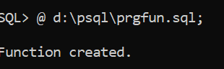

declare
c number(2);
begin
c:=totalCustomers();
dbms_output.put_line(' Total no.of customers:' || c);
end;
/

Note:- save above prg (here it is prgfun1.sql)

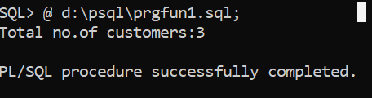

Week12:-

21.Create a function to check whether a given string is palindrome or not.

SQL>edit palindrome.sql

SUB PROGRAM:

create or replace function palin(s1 varchar2) return varchar2 as

s2 varchar2(20);

s3 varchar2(20);

begin

s2:=s1;

select reverse (s2) into s3 from dual;

return s3;

end;

MAIN PROGRAM:

SQL>declare

a varchar2(20);

b varchar2(20);

begin

a:=&a;

b:=palin(a);

if a=b then

dbms_output.put_line('palindrome');

else

dbms_output.put_line('not a palindrome');

end;

/

***************************************************************************

